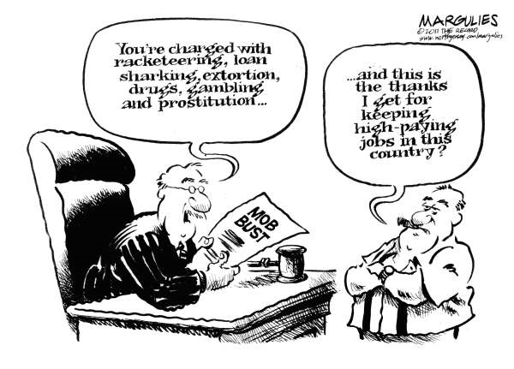from http://www.politicalcartoons.com/

Pick One to analyze for Questions:
Pick One to analyze for Questions: Answer the following questions:
Definition of satire - a work of art or literature that tries to change something by making you laugh.
What is the cartoon or top ten list making fun of?
__________________________________________________________________________________________________________________________________________________________________________________________________________________________________________________________________________________________________________________________________________
What social practice is the artist trying to change? (Why did the artist draw the piece?)
________________________________________________________________________________________________________________________________________________________________________________________________________________________________________________________________________________________________________________________________________________________________________________________________________________________
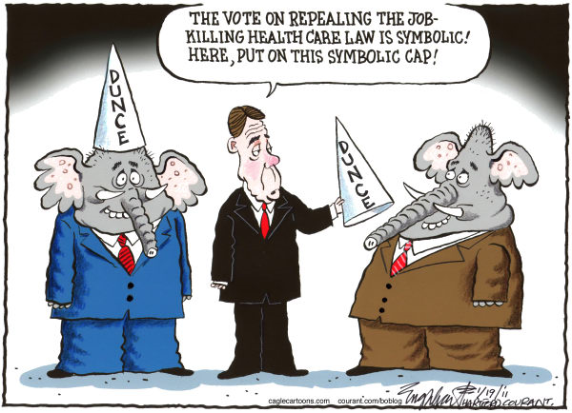Late Show Top Tens
Friday, January 04, 2011
Top Ten New York Department of Sanitation Excuses
10.It was cold
9.Couldn't get to work because no one plowed the street
8.Didn't want to get hit by falling dead birds
7.What do we look like? Ice road truckers?
6.Work slowdowns, sleeping on the job... Shouldn't you be questioning the New York Giants?
5.Wait, New York City has a Department of Sanitation?
4.Waiting for Apple to develop a snow removal app
3.Still have our hands full cleaning up Charlie Sheen's hotel room
2.Distracted watching Rex Ryan home movies
1.We always pull crap like this during the holidays

Monday, December 6, 2010
Top Ten Signs Your Neighbor Is The WikiLeaks Guy
10.Name on mailbox reads "WikiLeaks Guy"
9.Spends most of his free time burying stuff in the yard
8.He insists you speak directly into his necktie
7.More than once you've caught him crawling in your ventilation ducts
6.He told you about Jeter's new contract at Thanksgiving
5.He insists you speak directly into his necktie -- that joke was already in the Top Ten. We really need someone checking these things
4.On recycling day, he puts out cans, bottles, and classified documents
3.His idea of small talk is "Good morning" and "Want the coordinates of our secret military base in the Strait of Hormuz?"
2.Any time you talk to him, all he says is, "I know. I know. I know... "
1.Gets drunk and takes a "WikiLeak" on your porch -- Hi-yooo !

Definition of satire - a work of art or literature that tries to change something by making you laugh.
Choose one cartoon to answer the following questions:
What is the cartoon making fun of?
__________________________________________________________________________________________________________________________________________________________________________________________________________________________________________________________________________________________________________________________________________
What social practice is the artist trying to change? (Why did the artist draw the piece?)

___________________________________________________________________________________________________________________________________________________________________________________________________________________________________________________________________________________________________________________________________________________________________________________________________________________________________________________________________________

